**Nama : Ade Reiki Karuna  
NIM : A12.2020.06455  
Mata Kuliah : PBO**

**Tugas Praktik 4 (Struktur Kendali)**

**Latihan04a.java**

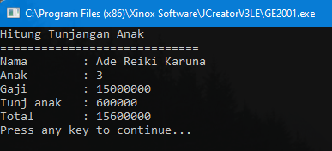

**Latihan04b.java**

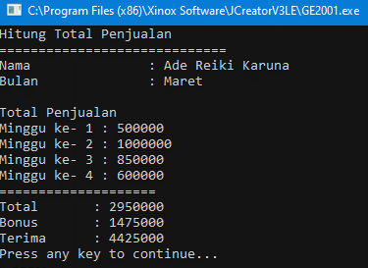

**Latihan03c.java**

*Source code tulis tangan :*

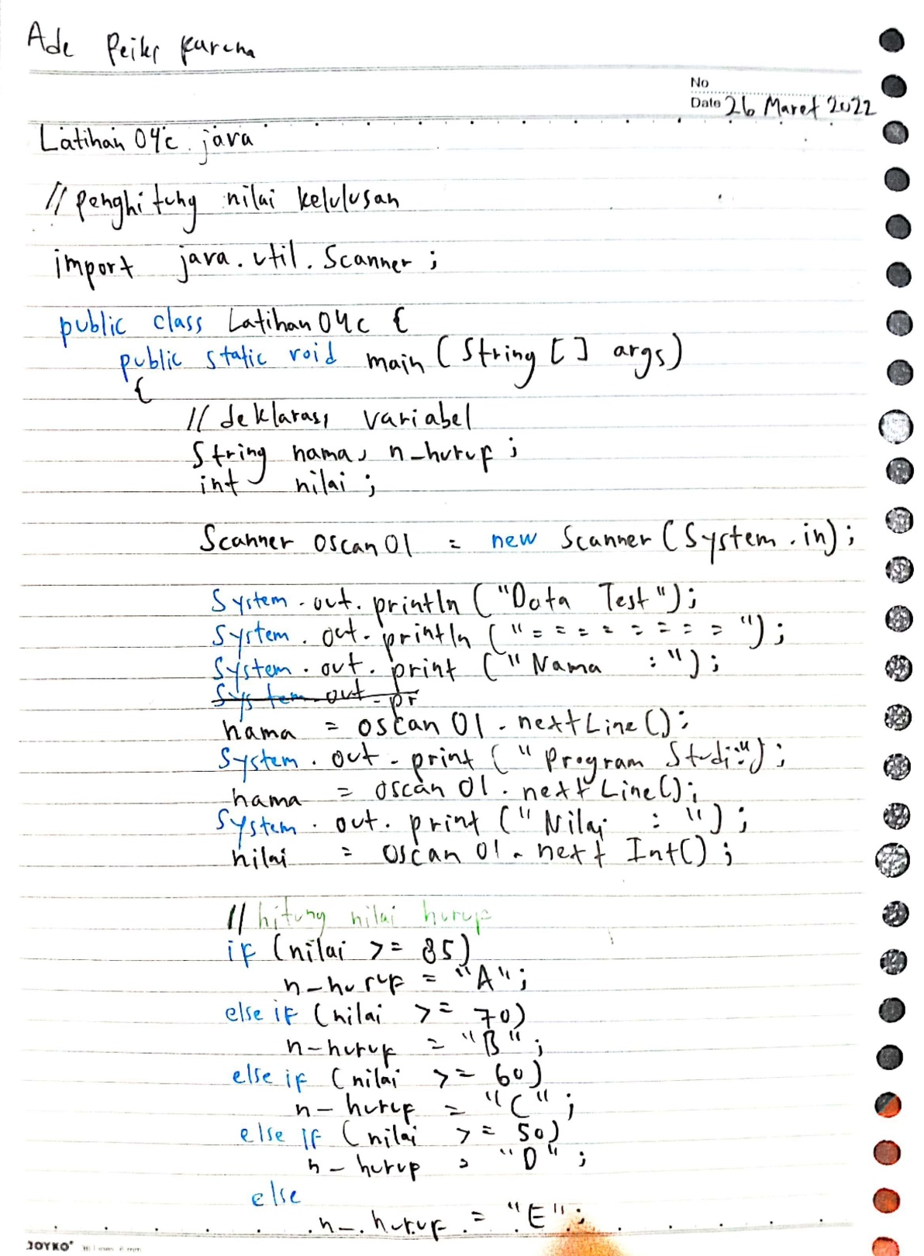

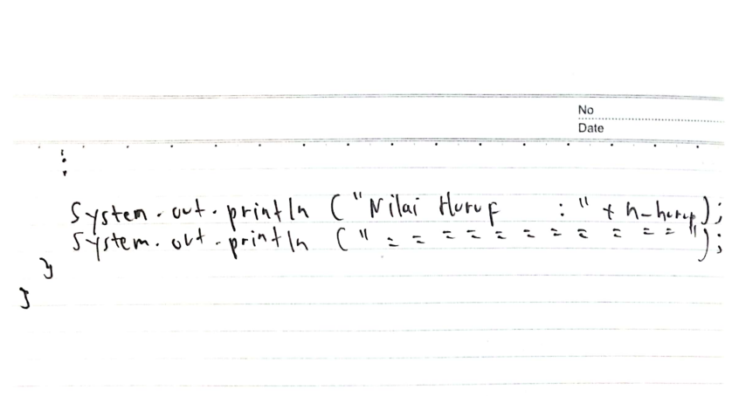

*Source code digital :*

*//penghitung nilai kelulusan*

import java.util.Scanner;

public class Latihan04c {

    public static void main(String[] *args*)

    {

*//deklarasi var*

        String nama, n_huruf;

        int nilai;

        Scanner oscan01 = new Scanner(System.in);

        System.out.println("Data Test");

        System.out.println("=============================");

        System.out.print("Nama               : ");

        nama = oscan01.nextLine();

        System.out.print("Program Studi      : ");

        nama = oscan01.nextLine();

        System.out.print("Nilai              : ");

        nilai = oscan01.nextInt();

*//hitung nilai huruf*

        if (nilai >= 85)

            n_huruf = "A";

        else if(nilai >= 70)

            n_huruf = "B";

        else if(nilai >= 60)

            n_huruf = "C";

        else if(nilai >= 50)

            n_huruf = "D";

        else

            n_huruf = "E";

        System.out.println("Nilai Huruf        : " + n_huruf);

        System.out.println("=============================");

    }

}

*Output :*

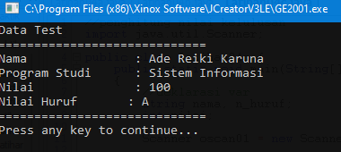

**Latihan03d.java**

*Source code :*

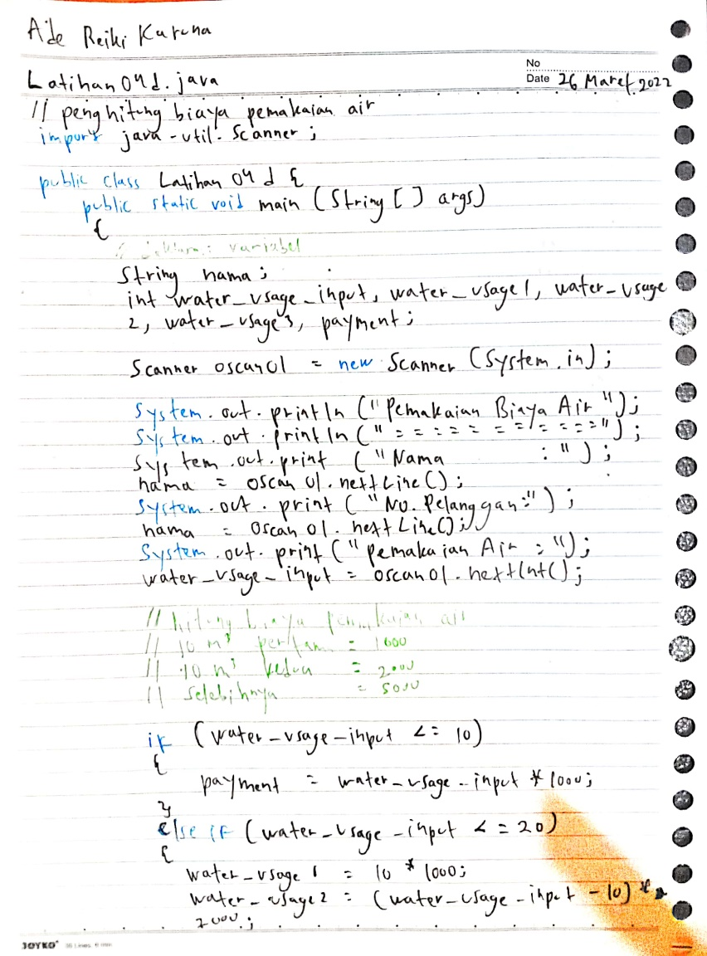

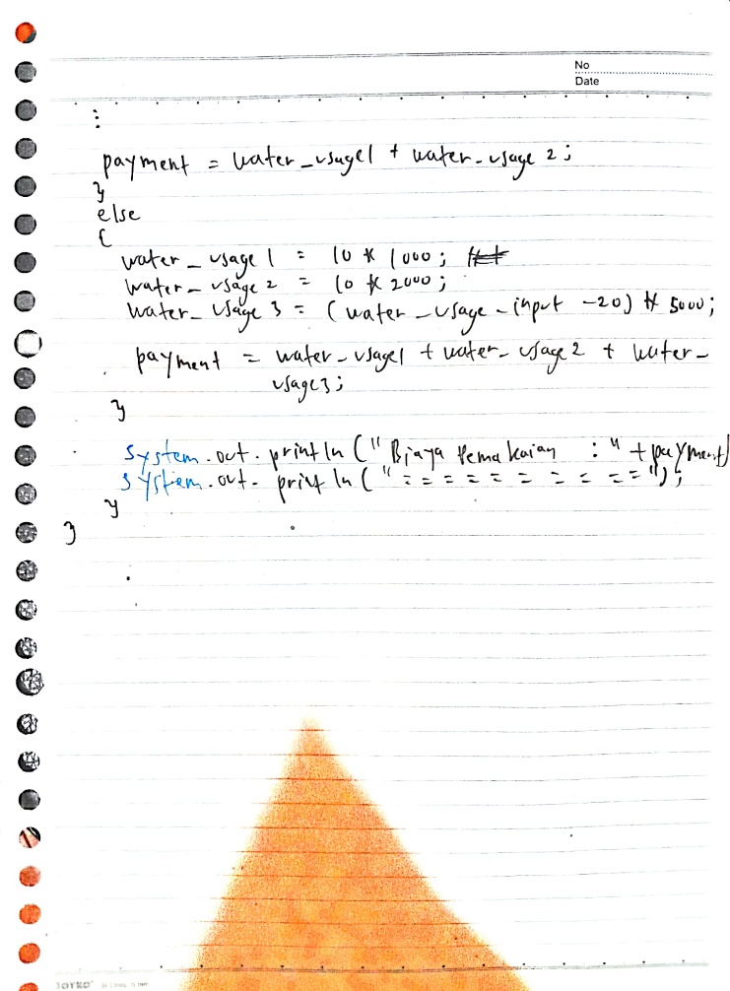

*Source code digital :*

*//penghitung biaya pemakaian air*

import java.util.Scanner;

public class Latihan04d {

    public static void main(String[] *args*)

    {

*//deklarasi var*

        String nama;

        int water_usage_input, water_usage1, water_usage2, water_usage3, payment;

        Scanner oscan01 = new Scanner(System.in);

        System.out.println("Perhitungan Biaya Pemakaian Air");

        System.out.println("=============================");

        System.out.print("Nama               : ");

        nama = oscan01.nextLine();

        System.out.print("No. Pelanggan      : ");

        nama = oscan01.nextLine();

        System.out.print("Pemakaian Air      : ");

        water_usage_input = oscan01.nextInt();

*//hitung biaya pemakaian air*

*// 10 m3 pertama = 1000*

*// 10 m3 kedua   = 2000*

*// selebihnya    = 5000*

        if (water_usage_input <= 10)

        {

            payment = water_usage_input * 1000;

        }

        else if(water_usage_input <= 20)

        {

            water_usage1 = 10 * 1000;

            water_usage2 = (water_usage_input - 10) * 2000;

            payment = water_usage1 + water_usage2;

        }

        else

        {

            water_usage1 = 10 * 1000; *//10.000*

            water_usage2 = 10 * 2000; *//20.000*

            water_usage3 = (water_usage_input - 20) * 5000;

            payment = water_usage1 + water_usage2 + water_usage3;

        }

        System.out.println("Biaya Pemakaian    : " + payment);

        System.out.println("=============================");

    }

}

*Output :*

